**DAILY ONLINE ACTIVITIES SUMMARY**

|  |  |  |  |  |  |  |  |  |
| --- | --- | --- | --- | --- | --- | --- | --- | --- |
| **Date:** | **09/06/2020** | | | | | **Name:** | **Apoorva H P** | |
| **Sem & Sec** | **6th sem & A sec** | | | | | **USN:** | **4AL17CS011** | |
| **Online Test Summary** | | | | | | | | |
| **Subject** | | **CGV IA Test 4 and CNSC IA Test - 3(retest)** | | | | | | |
| **Max. Marks** | | **CGV - 30**  **CNSC - 60** | | **Score** | | | **CGV - 26**  **CNSC - 36** | |
| **Certification Course Summary** | | | | | | | | |
| **Course** | **Front end Development-HTML** | | | | | | | |
| **Certificate Provider** | | | **Great Learning** | | **Duration** | | | **3.5hr** |
| **Coding Challenges** | | | | | | | | |
| **Problem Statement:**   1. Python Program to Check Whether a String is a Palindrome or not Using Recursion. 2. Python Program to Reverse a String Using Recursion. | | | | | | | | |
| **Status: Completed** | | | | | | | | |
| **Uploaded the report in Github** | | | | | **Yes** | | | |
| **If yes Repository name** | | | | | <https://github.com/ashaapoorva/online-coding-and-certification-course> | | | |
| **Uploaded the report in slack** | | | | | **Yes** | | | |

**Online Test Details**

CGV IA Test 4 and CNSC IA 3 retest Details:

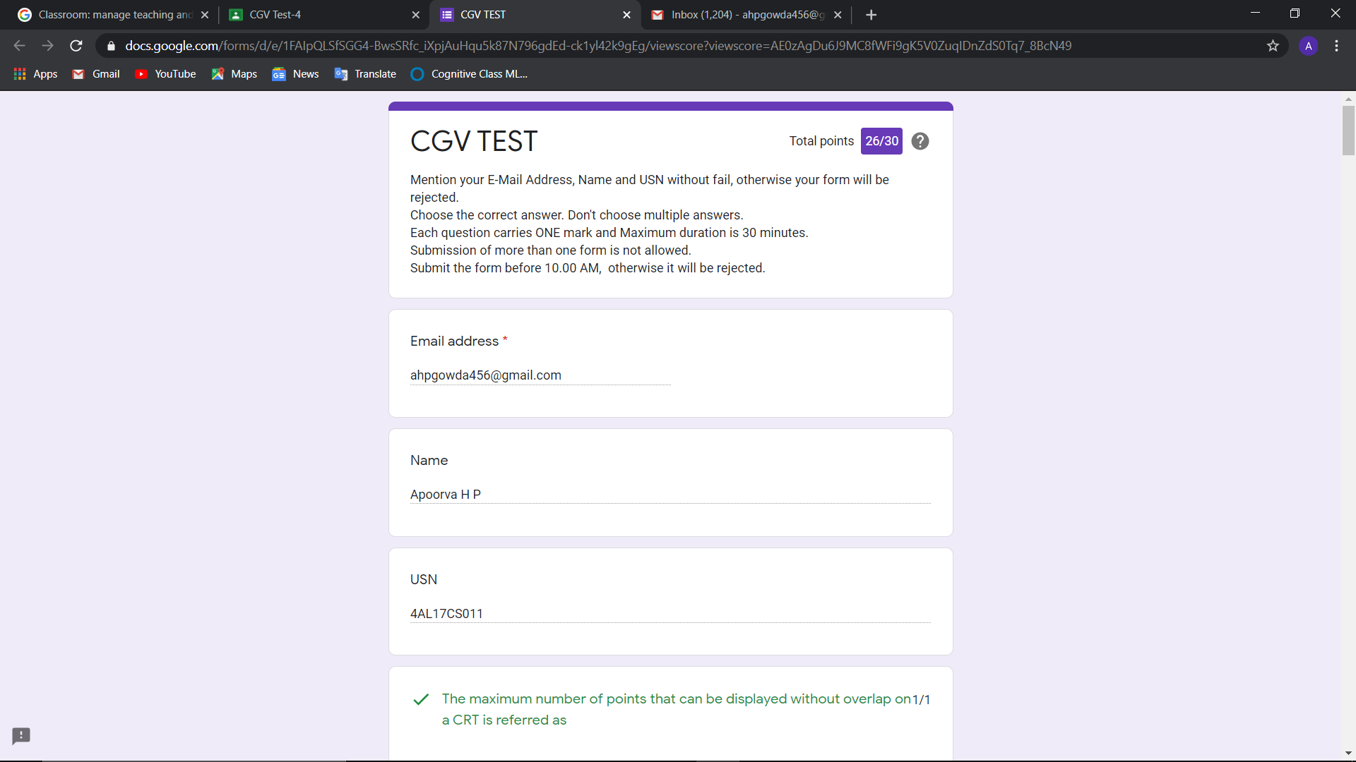

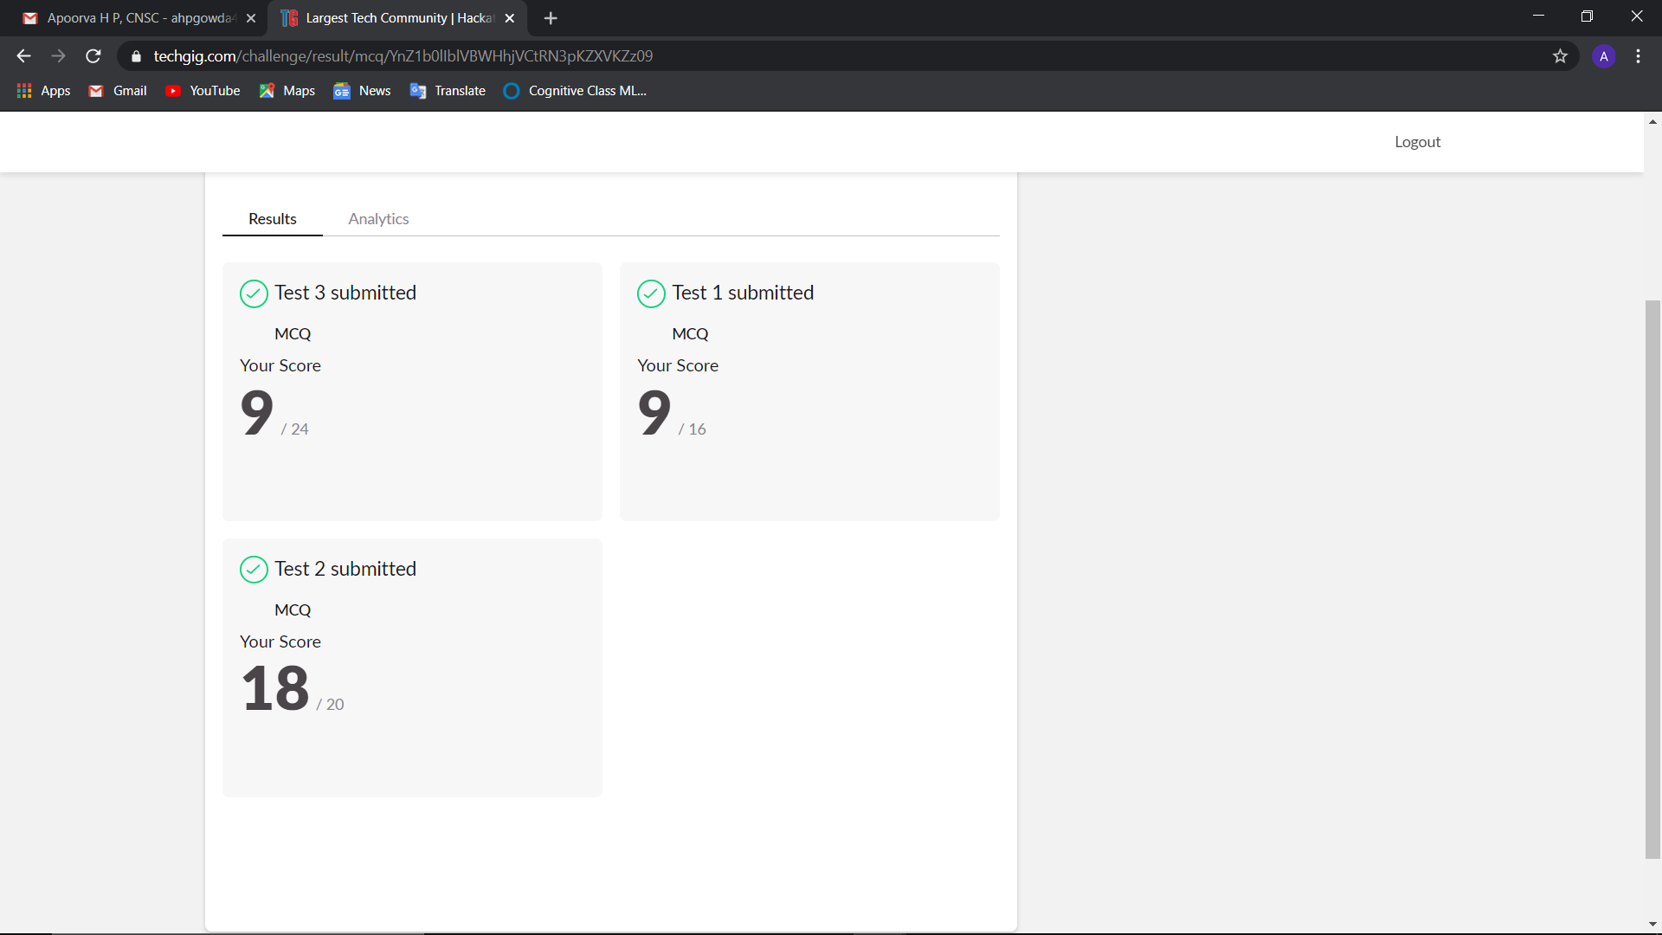

**Online Certification Details**

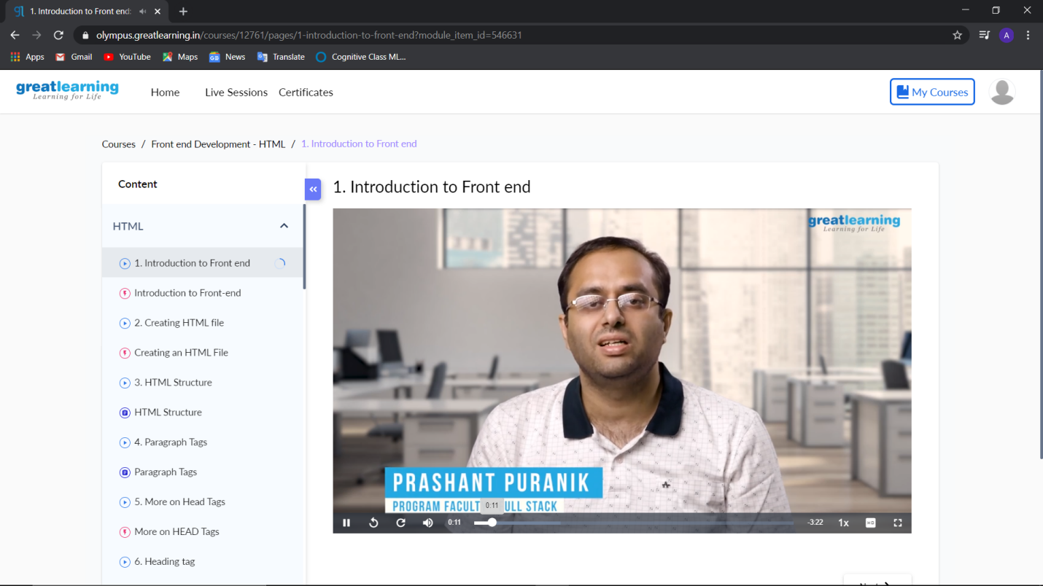

**Coding Challenge Details**

1. Python Program to Check Whether a String is a Palindrome or not Using Recursion.

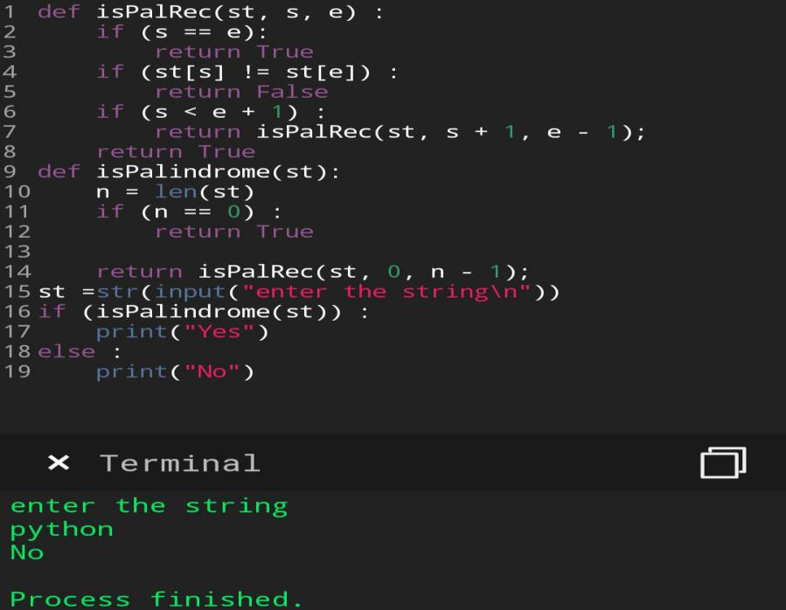

1. Python Program to Reverse a String Using Recursion.

